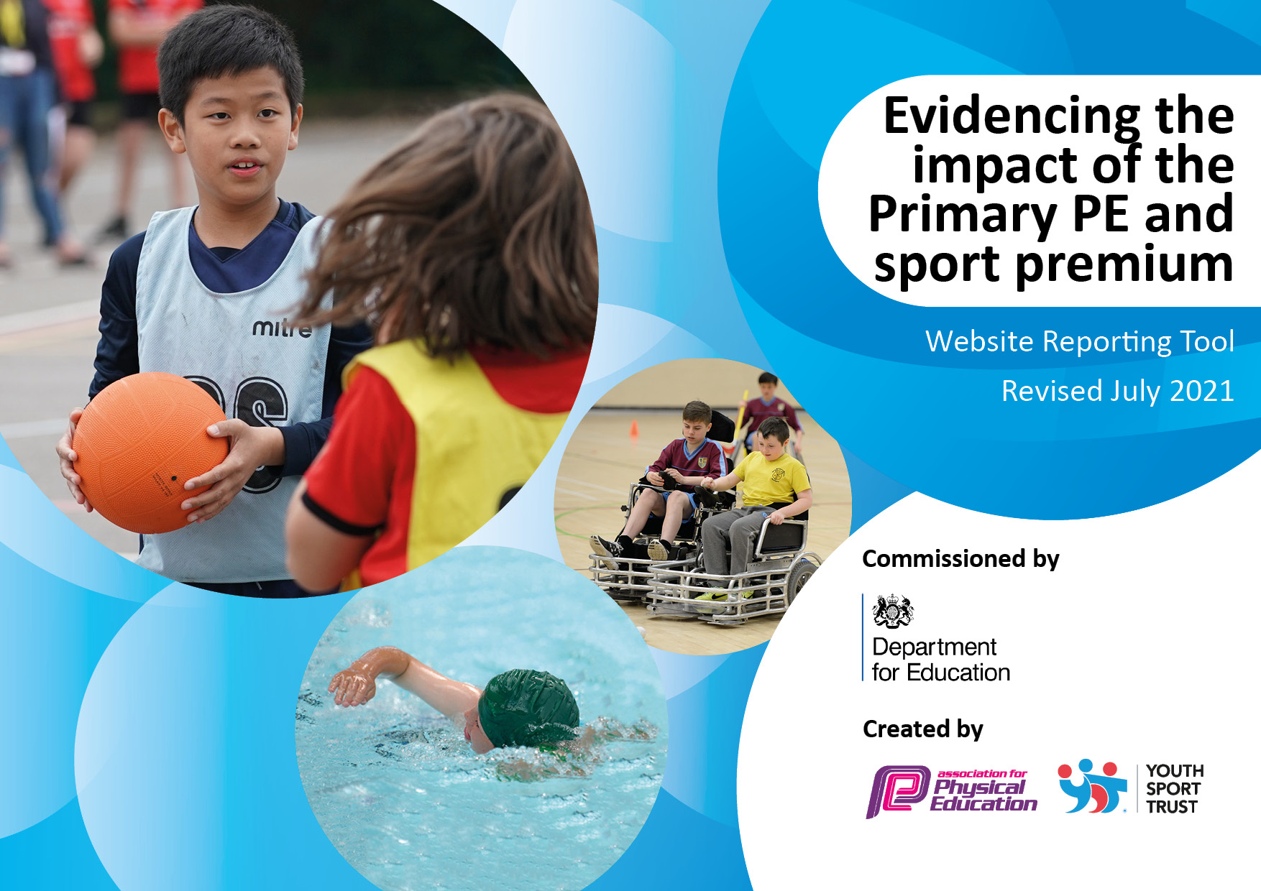
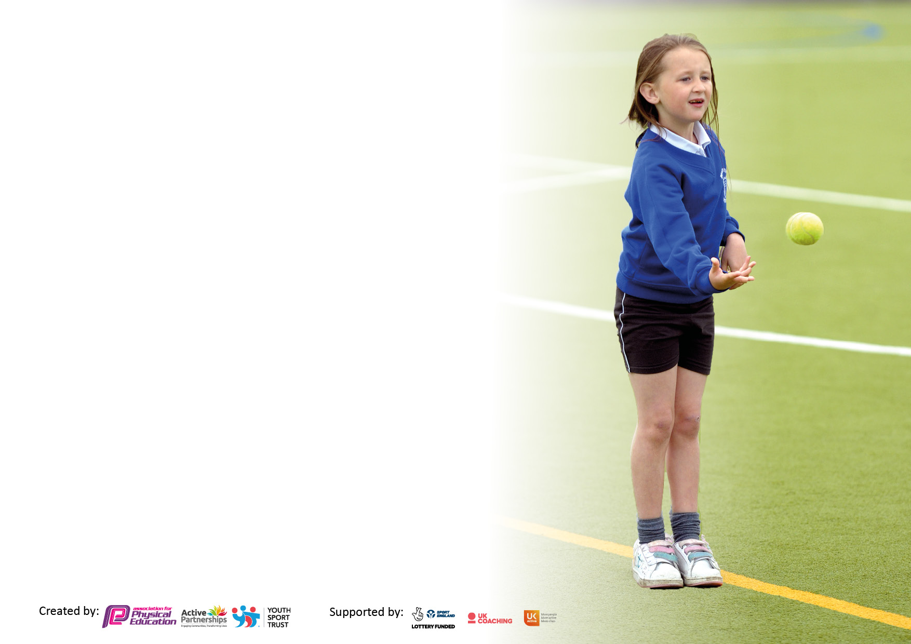

It is important that your grant is used effectively and based on school need. The Education Inspection Framework makes clear there will be a focus on ‘whether leaders and those responsible for governors all understand their respective roles and perform these in a way that enhances the effectiveness of the school’.

Under the Quality of Education Ofsted inspectors consider:
Intent - Curriculum design, coverage and appropriateness
Implementation - Curriculum delivery, Teaching (pedagogy) and Assessment
Impact - Attainment and progress

To assist schools with common transferable language this template has been developed to utilise the same three headings which should make your plans easily transferable between working documents.

Schools must use the funding to make additional and sustainable improvements to the quality of Physical Education, School Sport and Physical Activity (PESSPA) they offer. This means that you should use the Primary PE and sport premium to:

- Develop or add to the PESSPA activities that your school already offer
- Build capacity and capability within the school to ensure that improvements made now will benefit pupils joining the school in future years
- The Primary PE and sport premium should not be used to fund capital spend projects; the school’s budget should fund these.

Pleasevisitgov.ukfortherevisedDfEguidanceincludingthe5keyindicatorsacrosswhichschoolsshoulddemonstrate animprovement.Thisdocumentwillhelpyoutoreviewyourprovisionandtoreportyourspend.DfEencouragesschools to use this template as an effective way of meeting the reporting requirements of the Primary PE and sport premium.

We recommend you start by reflecting on the impact of current provision and reviewing the previous spend.

Schools are required to publish details of how they spend this funding, including any under-spend from 2019/2020, as well as on the impact it has on pupils’ PE and sport participation and attainment. All funding must be spent by 31st July 2022.

We recommend regularly updating the table and publishing it on your website throughout the year. This evidences your ongoing self-evaluation of how you are using the funding to secure maximum, sustainable impact. Final copy must be posted on your website by the end of the academic year and no later than the 31st July 2021. To see an example of how to complete the table please click HERE.
Created by: Supported by:

Details with regard to funding
Please complete the table below.

Total amount carried over from 2020/21 | £0
Total amount allocated for 2021/22 | £18,062
How much (if any) do you intend to carry over from this total fund into 2022/23? | £0
Total amount allocated for 2022/23. To be spent and reported on by 31st July 2023 | £18,182
How much (if any) do you intend to carry over from this total fund into 2022/23? | £2,112
Swimming Data
Please report on your Swimming Data below.

Meeting national curriculum requirements for swimming and water safety.

N.B. Complete this section to your best ability. For example you might have practised safe self-rescue techniques on dry land which you can then transfer to the pool when school swimming restarts.
Due to exceptional circumstances priority should be given to ensuring that pupils can perform safe self rescue even if they do not fully meet the first two requirements of the NC programme of study
What percentage of your current Year 6 cohort swim competently, confidently and proficiently over a distance of at least 25 metres?  N.B. Even though your pupils may swim in another year please report on their attainment on leaving primary school at the end of the summer term 2021.  Please see note above | 45.16%
What percentage of your current Year 6 cohort use a range of strokes effectively [for example, front crawl, backstroke and breaststroke]?  Please see note above | 45.16%
What percentage of your current Year 6 cohort perform safe self-rescue in different water-based situations? | 45.16%
Schools can choose to use the Primary PE and sport premium to provide additional provision for swimming but this must be for activity over and above the national curriculum requirements. Have you used it in this way? | Yes/No

Action Plan and Budget Tracking
Capture your intended annual spend against the 5 key indicators. Clarify the success criteria and evidence of impact that you intend to measure to evaluate for pupils today and for the future.

Academic Year: 2022/23 | Total fund allocated: | Date Updated:
Key indicator 1: The engagement of all pupils in regular physical activity – Chief Medical Officers guidelines recommend that primary school pupils undertake at least 30 minutes of physical activity a day in school |  |  |  | Percentage of total allocation:
 |  |  |  | %
Intent | Implementation |  | Impact
Your school focus should be clear what you want the pupils to know and be able to do and about  what they need to learn and to  consolidate through practice: | Make sure your actions to achieve are linked to your intentions: | Funding allocated: | Evidence of impact: what do pupils now know and what can they now do? What has changed?: | Sustainability and suggested next steps:
To increase activity levels across school  TAGTIV8  To invest in outdoor learning with a focus in increasing activity levels.  Frickley Lunchtime club – to use coaches from the local football community foundation to help increase physical activity at lunchtimes | Taking part in the Creating Active School Framework.  Physical activity policy  Assembly to raise profile in school  form ‘Active Crew’  Active crew to be trained as sports leaders.  Work alongside Frickley Athletic to increase purposeful activity at lunchtimes.  Provide opportunities for children to attend festivals and competitions.  Parent/child voice – after school club offerings.  Organise staff CPD  Buy resources for implementation  Contact Tagtiv8 and arrange a taster day  All children to be encouraged to participate in their class session on lunchtimes | £195 annual subscription  Resources £725  Staff CPD £350  £3,535 | Regular CAS meetings with schools in the project that shares good practice and updates on the project.  Assembly delivered about physical activity to school – Years 1 – 6 as a result children are more aware of the need to be active and the benefits of this too.  Active crew has been introduced to the children.  .  More movement breaks are being used throughout school and staff and pupils are benefitting form this.  No specific CPD, other than working with sports coach is needed at this time.  Due to other school priorities – Tagtiv8 to be arranged at a later date.  Frickley now come in every lunchtime and provide different sports opportunities throughout the week to encourage physical activity at lunchtime | Make parents/child voice a priority for the next year to further inform our PE/physical activity offer within school.  From CAS meetings – look at how best to use classrooms and corridors to promote active breaks and purposeful physical activity.  Carry on with Frickley and the lunchtime club.
Key indicator 2: The profile of PESSPA being raised across the school as a tool for whole school improvement |  |  |  | Percentage of total allocation:
 |  |  |  | %
Intent | Implementation |  | Impact
Your school focus should be clear what you want the pupils to know and be able to do and about  what they need to learn and to  consolidate through practice: | Make sure your actions to achieve are linked to your intentions: | Funding allocated: | Evidence of impact: what do pupils now know and what can they now do? What has changed?: | Sustainability and suggested next steps:
Sport and Wellbeing Week - to improve knowledge within all stakeholders of how to live a healthy lifestyle  CAS project  To increase the importance of implementation of physical activity throughout the curriculum at Moorthorpe by working with Helen Cartwright from Creating an Active School Framework | Contact Peter Ward at Health and Improvement  Arrange a date for the healthy week  Arrange for different activities within that week – stationary bikes  Blazepod sessions etc  Link with cooking and have cooking sessions - ingredients  Cover costs to arrange  Assemblies  Display  Visitors  New kit for LKS2 (no cost)  Forest school | £ 500  £2.600 | A specific week was not able to happen however, other various events have taken place such as bikeablity and the reindeer run.  We have secured the Healthy Wakefield Charter Mark  Our partnership with the Health improvement is still strong and plans for next year are being drawn up such as roller biking and promoting the council  Regular CAS meetings with schools in the project that shares good practice and updates on the project. | Set date for Healthy Week next academic year – Liaise with Peter Ward and the Health improvement team.  Our school to host one of the group meetings to showcase what we are implementing in our school.

Key indicator 3: Increased confidence, knowledge and skills of all staff in teaching PE and sport |  |  |  | Percentage of total allocation:
 |  |  |  | %
Intent | Implementation |  | Impact
Your school focus should be clear | Make sure your actions to | Funding | Evidence of impact: what do | Sustainability and suggested
what you want the pupils to know | achieve are linked to your | allocated: | pupils now know and what | next steps:
and be able to do and about | intentions: |  | can they now do? What has
what they need to learn and to |  |  | changed?:
consolidate through practice:
To increase confidence and subject knowledge for staff delivering PE lessons  To further develop subject knowledge and keep up to date with changes in the subject | - Purchased Getset4PE scheme from last years Sports premium – continue to plan and assess using the scheme.  - Staff to work alongside coach – Martin Stringfellow, to team teach and deliver parts of the lesson for their own CPD.  Attend Wakefield PE conference | £ No cost  £7,230 est  £50 | Staff have expressed that they are more confident in delivering PE and Getset4PE has been a positive addition. Pupils are more engaged in these lessons due to the resources etc that the scheme provides,  Staff continue to gain skills and knowledge from Martin and work alongside him when delivering the lessons. If Martin is absent then staff are able to carry on the delivery and are confident in doing so. | Continue with Getset4PE.  PE lead to monitor delivery of lessons.  Staff voice
Key indicator 4: Broader experience of a range of sports and activities offered to all pupils |  |  |  | Percentage of total allocation:
Intent | Implementation |  | Impact
Your school focus should be clear | Make sure your actions to | Funding | Evidence of impact: what do | Sustainability and suggested
what you want the pupils to know | achieve are linked to your | allocated: | pupils now know and what | next steps:
and be able to do and about | intentions: |  | can they now do? What has
what they need to learn and to |  |  | changed?:
consolidate through practice:
Balance bikes -to provide our younger children with the opportunity to build skills that will enable them to learn to ride a bike more successfully.  Competitons/Links with Minsthorpe  Martin Stringfellow - After school football boys and girls  Inter school football matches. | Research the correct bikes and which would be more suitable for our children.  Contact Peter Ward – health and improvement about  SLA service level agreement with local high school  Arrange a clubs for both boys and girls and also competitions for each with local schools. | £139 per bike  X 10  £1390.00  Helmets x10 @£10  £1000  See figure for M.Stringfellow | Children have shown increased ability using the balance bikes and prefer to use these rather than trikes. We have seen improvement in balance skills.  We continue to participate in all of these competitions and compete well and with much improved success.  Well attended with both boys and girls | Provide a bike shed for storage Maintain bikes – possibly think about purchasing a few pedal bikes to further develop the children’s skills.  Try and take part in more 5 towns events against schools across the district.  Arrange competitions between local schools.

Key indicator 5: Increased participation in competitive sport |  |  |  | Percentage of total allocation:
 |  |  |  | %
Intent | Implementation |  | Impact
Your school focus should be clear | Make sure your actions to | Funding | Evidence of impact: what do | Sustainability and suggested
what you want the pupils to know | achieve are linked to your | allocated: | pupils now know and what | next steps:
and be able to do and about | intentions: |  | can they now do? What has
what they need to learn and to |  |  | changed?:
consolidate through practice:
To include ALL pupils – physically active or not to take part in competitions offered by our local school and also Yorkshire Sport | Attend all competitions when able to do so | £ 0 | Won the competition with Pontefract schools for the children who are not as active as those who usually attend competitive sport competitons.

Signed off by
Head Teacher: | Debroah Birdsall
Date: | 30th November 2023
Subject Leader: | Emma Jackson
Date: | 30th November 2023
Governor: | Terry Mottram
Date: | 30th November 2023

